Paper Title for Manuscripts Preparation (Paper Title Style)
First Author¹, Second Author^{2,*}, Third Author³ (Author Style)
¹ Chemical Education, Lampung University, Bandar Lampung, 35145, Lampung, Indonesia
² Physics Department, Lampung University, Bandar Lampung, 35145, Lampung, Indonesia
³ Agrotechnology, University of Lampung, Bandar Lampung, 35145, Lampung, Indonesia (Affiliation Style)

Abstract.
The instruction for the preparation of the full manuscript is detailed in this template file. The template is intended as a tool to assist you in the layout of your manuscript. It is encouraged that this template can be used for submission of manuscripts. Use of the template will save time during production and expedite publication. (Abstract Style)
Keywords.
Instruction, Manuscript Format, Submission, Publication, Layout. (Keywords Style)
INTRODUCTION (Section Style)
This template is formatted according to advice of some experts. All settings about fonts, point sizes and line spacing have been defined in the styles menu. (Figure 1) Use this document as a template if you are using Microsoft Word 2010 or higher. The Manuscript length should contain 5 pages at least. It should be in a two-column format. In general, a full manuscript consists of "Introduction", "Objectives", "Methods", "Results", "Discussion" and "Conclusions". English is treated as the only written language throughout the text.
The introduction shows what is already known from the previous studies, defines the importance of the study, literature review, and the research objectives. In order to understand what is already known from the previous studies, the introduction must consist of discussions of relevant journal articles (with citations) and a summary of the current understanding of the problem to show novelty of the research. (Paragraph Style)
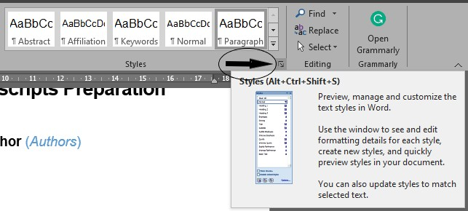
Figure 1. Show the Styles window (Figure Caption Style)
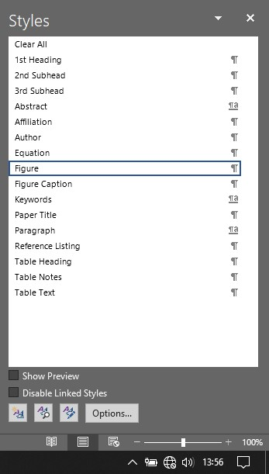 (Figure Style)
Figure 2. Change Style → Style Menu
METHODS
Present the research design, research type, research duration, inclusion/exclusion criteria, choice of subjects, etc. Describe the methodology completely, including sample collection, processing, lab analysis, statistical tests used for data analysis etc. Use section headings/subheadings in a logical order to entitle each category or method. A maximum of three levels of headings may be used. Usually, headings are numbered with Arabic numerals (1., 2.; 1.1., 1.2.; 1.1.1., 1.2.1….). It’s preferred to illustrate with tables and figures.
Paper Title (Subsection Style)
A paper should have a short, straightforward title directed at general readers in no more than 20 words.
Authorship
List the first and last names of all authors. Provide the full affiliation for each author including Department, University, City, Zip Code, State, Country. If any of the co-authors are from different organizations, their affiliation should be numbered with different Arabic numerals. Email address is compulsory for the corresponding author.
Abstract & Keywords
All manuscripts must contain an abstract, which summarizes the purposes of the work, the methods, the most significant results, and the conclusions. The abstract should not exceed about 300 words. The abstract must be able to stand alone because it is presented separately from the article. References should be avoided, but if essential, then cite the author(s) and year(s).
Immediately after the abstract, 3-5 words or short phrases should be included for online searching (e.g. Keywords Instruction, Manuscript Format, Submission, Publication, Layout).
Figures
Figures Caption (Subsubsection Style)
Each figure should have a caption. The caption should be concise and typed separately, not on the figure area; If figures have parts (for example, A and B), make sure all parts are explained in the caption.
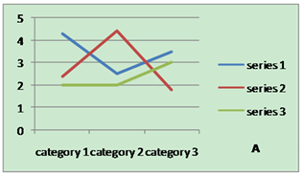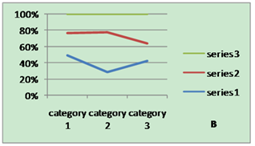
Figure 3. Picture A and Picture B
Figures Numbering & Citation
All figures are to be sequentially numbered with Arabic numerals. Figures should always be cited in consecutive numerical order. (Figure 3) Parts in a figure can be identified by A, B, C etc.
Figures Resolution
Figures must be created at a minimum resolution of 300 dpi to avoid bad printing quality. For fuzzy or jagged figures, authors are required to replace it or send the original figure file to us for reproduction.

Tables
Tables Title
Every table must have a unique title placed at the top. Titles should be clear and concise, and they should not be complete sentences.
Tables Format
Table tools in Microsoft Word are recommended for inserting a table. It’s necessary to avoid tables created with the tab key.
Tables Numbering & Citation
Tables in the main body of the text should be numbered consecutively according to its appearance in the text. Cite each table in numerical order.
Table 1. Specific data of Column/Row (Table Heading Style)
Number (Table Text Style + Bold) | Column Header 1 | Column Header 2
Row Header 1 (Table Text Style) | X (Table Text Style) | X (Table Text Style)
Row Header 2 | X | X
Row Header 3 | X | X
Equation
Equation Format
The equation number should be placed in parentheses to the right of the equation. Do not create equations as pictures. Use MathType or insert symbols as normal text.
Equation as normal text:
E=MC²$\sin{α}±\sin{β}=2\sin{\frac{1}{2}\left(α±β\right)}\cos{\frac{1}{2}\left(α∓β\right)}$ (Equation Style) (1)
Equation created by MathType:
(2)
Equation Numbering & Citation
Equations should be numbered consecutively with Arabic numerals to avoid ambiguities, if they will be referred to in text. Citation for an equation should be made by using “(1),” not “Eq. (1)” or “equation (1),” except at the beginning of a sentence: “Equation (1) is…”
Reference Style
All sources cited in text must appear in the reference list, and all items in the reference list must be cited in text. With the numerical system, references are arranged in the reference list so that they match the order in which they are cited in the text. Written in the style of the e-Journal, as stated in the Guidelines for this journal (which ratifies APA Edition VI). Some examples of how to write references / references in the Reference List are given below. This journal requires reference at least 80% of primary referral sources (national and international journals) of the last 10 years of publication.
Reference in-Text Citation Format
References are simply cited with the consistent reference number in square brackets. Do not set references number as superscript number. Do not use “Ref. [3]” or “Reference [3]” except at the beginning of a sentence, e.g. “Reference [3] shows …”
A. Single Reference
If the author's name appears in the text, place the reference number immediately after the name.
E.g. Peter[1] found an innovative scientific phenomenon.
B. Multiple References
1) Put two or four numbers in numerical order and separate them by commas but no spaces.
E.g.: [2,3]
2) Indicate three or more consecutive reference numbers by giving the first and last numbers separated by a hyphen.
E.g.: [3-5]
List of References
Authors are requested to check all references for completeness, including author names, paper title, publisher, journal heading, Volume, Number., pages for journal citations, Year.
Books
All author names, Year , Book title, Country, Publisher.
e.g. Beverley, B. (1993). Children’s Science, Constructivism and Learning in Science (Second Edition). Victoria: Deakin University Press.
Journals
All author names, Year , Title, Journal title, Vol, No, pp,
e.g. Astuti, P., & Lammers, J. C. (2017). Individual accountability in cooperative learning: More opportunities to produce spoken English. Indonesian Journal of Applied Linguistics, 7 (1), 215-228.
Conference Papers
All author names, Title, Conference title, pp, Year.
e.g. Simsek, P. & Kabapmar (2010). The effects of inquiry-based learning on the elementary students conceptual understanding of matter, scientific process skills and science attitudes. World Conference on Educational Sciences, Bahcesehir University, 4-8 February 2010. Istanbul, Turkey: Elsevier.
Websites
Online Available: http:// e.g.: Cole, P. 2005. How Irregular is WH in Situ in Indonesian. Retrieved from http://www.ling.udel.edu/pcole/How_Irregular html, on 18 Mei 2005.
RESULT AND DISCUSSION
The research results are presented in the form of graphs, tables, or descriptive. Analysis and interpretation of these results is needed before discussion. The discussion should include merit journal aspects (what/how?, why?, and what else?).
The results of the study are presented in the form of graphs, tables, or descriptive. Analysis and interpretation of these results is needed before being discussed.
The discussion focused on linking the data and the results of its analysis to the problem or purpose of the study and the broader theoretical context. It can also be discussed is the answer to the question why are facts found in the data. The discussion is written attached to the data discussed. The discussion is attempted not to be separated from the data discussed. Results and Discussion have proportion about 60-70% of the manuscript. This part is the main part of the research article. Results should summarize or highlight the findings rather than providing the detailed research results. The results also contain the results taken from the data analysis and/or the hypothesis test results and only provide the data that support discussion. This part includes table(s) and graph(s) taken from the research results data.
Discussion plays the important part in a scientific article. This part answers the problems, interprets the research results and the findings into the already known knowledge, confirms and/or contrasts with the research of other researchers, constructs the new theory, and/or modifies the previous theory. Discussion may also contain the implications of both theoretical and implementation results. Results and Discussion should answer what, why and what else questions. The research findings must be stated explicitly. After stating the research findings, the research findings and the relevant theory or hypothesis must be discussed comprehensively. The discussion section also must explain the comparison of the research finding with the relevant results. Therefore, a notable citation must be found in the discussion section. In the last part, the implication of the research finding to sciences should be stated clearly.
CONCLUSION
Any comments and suggestions are welcomed so that we can constantly improve this template to satisfy all authors’ research needs.
ACKNOWLEDGEMENTS (Section Style)
We are very grateful to experts for their appropriate and constructive suggestions to improve this template (Optional).
REFERENCES (Section Style)
- Beverley, B. (1993). Children’s Science, Constructivism and Learning in Science (Second Edition). Victoria: Deakin University Press. (Reference Listing Style)
- Astuti, P., & Lammers, J. C. (2017). Individual accountability in cooperative learning: More opportunities to produce spoken English. Indonesian Journal of Applied Linguistics, 7 (1), 215-228.
- Simsek, P. & Kabapmar (2010). The effects of inquiry-based learning on the elementary students conceptual understanding of matter, scientific process skills and science attitudes. World Conference on Educational Sciences, Bahcesehir University, 4-8 February 2010. Istanbul, Turkey: Elsevier.
- Cole, P. 2005. How Irregular is WH in Situ in Indonesian. Retrieved from http://www.ling.udel.edu/pcole/How_Irregular html, on 18 Mei 2005.

